**NIIT UNIVERSITY**

**NEEMRANA 301705, Dist. Alwar (Rajasthan)**



Mid report

|  |
| --- |
| **Project Title:** Database of Travel Portal |

**Course Name:** Database Management System

**Course Code:** CS231

**Year:** 2nd **Semester:** 4th

**Session:** 2017-18 **Discipline:** CSE

**Group Members**

Anirudh Sharma, U101116FCS009  
Harshil Sachdeva, U101116FCS044

Harshit, U101116FCS184

Jatin Ninawe, U101116FCS051

Prakriti pritmani, U101116FCS090

**Contents**

1. Project description
2. ER diagram
3. Relational Database
4. Functional dependencies
5. Normalization
6. SQL code

**PROJECT DESCRIPTION**

We are building a database for travel portal. We came up with an idea of how the travel agency should look like. In this report, we are focusing on the ER Diagram, relational table, and the functional dependencies.

**ER Diagram**

* **Entities used-**

1. **Activities:**

**Attributes-** ACTIVITY_ID(Primary key), LOCATION_ID(Foreign key), A_DESCRIPTION, A_NAME.

1. **Location:**

**Attributes-** LOCATION_ID(Primary key), L_NAME.

1. **Transportation:**

**Attributes-** TRANSPORTATION_ID(Primary key), T_TYPE.

1. **Stay:**

**Attributes-** STAY_ID(Primary key), LOCATION_ID, S_PRICE, S_NAME.

1. **Package:**

**Attributes-** PACKAGE_ID(Primary key), P_NAME.

1. **Customer:**

**Attributes-** CUSTOMER_ID(Primary key), C_NAME, C_NUMBER, C_EMAIL, C_SEX, C_ADDRESS.

Here, C_ADDRESS is a composite attribute and contains two more attributes in it : C_ADDRESS(CITY, STREET_NAME).

1. **Facilities:**

**Attributes-** FACILITY_ID(Primary key), F_GYM, F_SPA, F_SPORTSCOMPLEX.

1. **Amenities:**

**Attributes-** AMENITY_ID(Primary key), A_ELECTRICITY, A_ROOMSERVICE, A_WIFI, A_BEDandBREAKFAST.

1. **Hotels:**

**Attributes-** HOTEL_ID(Primary key), H_RATING, H_NAME, H_AVAILABILITY.

1. **Home stay:**

**Attributes**- HOMESTAY_ID(Primary key), HS_ROOMS, HS_AVAILABILITY, HS_NAME.

1. **Booking:**

**Attributes-** BOOKING_ID(Primary key), B_STATUS, B_PRICE.

* **RELATIONS-**
* Each customer books a package based on the booking status.
* Each package comprises of transportation mode and place of stay.
* In each package, we offer various staying options at the location via different transportation modes.
* At your stay, we offer many facilities like spa, gym, etc which includes amenities as well.
* There are two options to stay - hotels and home stay.

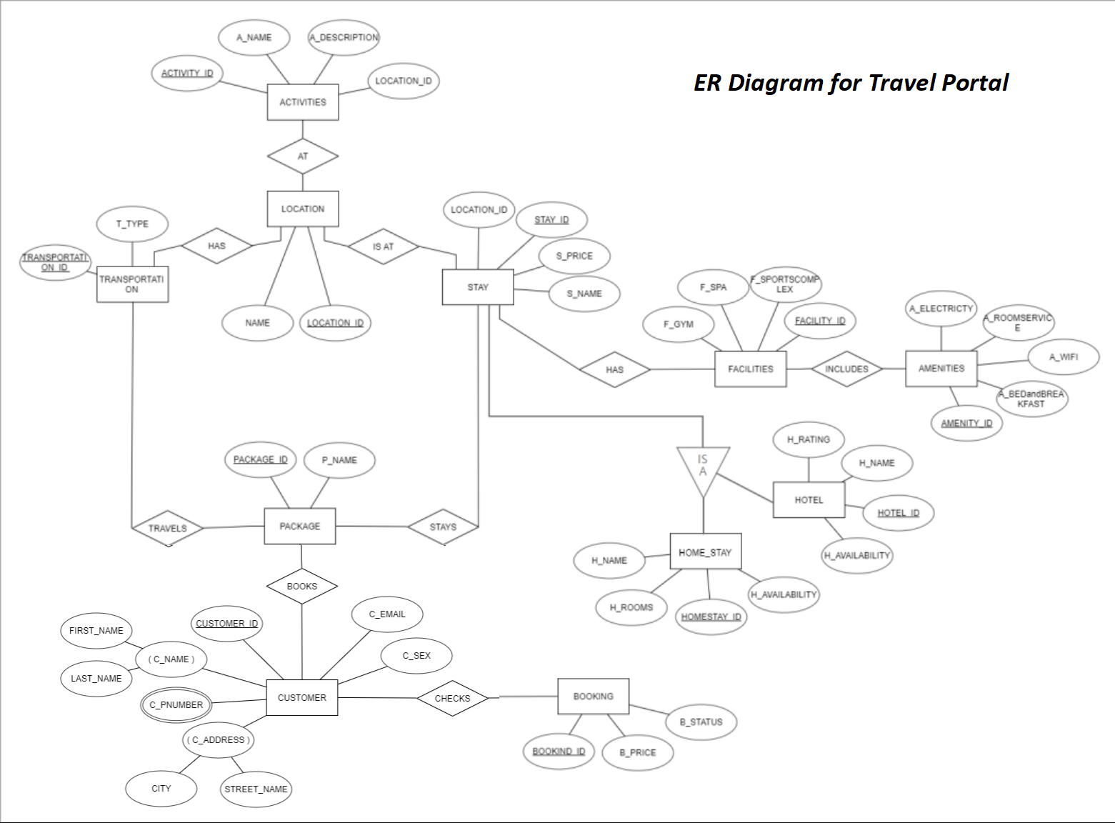

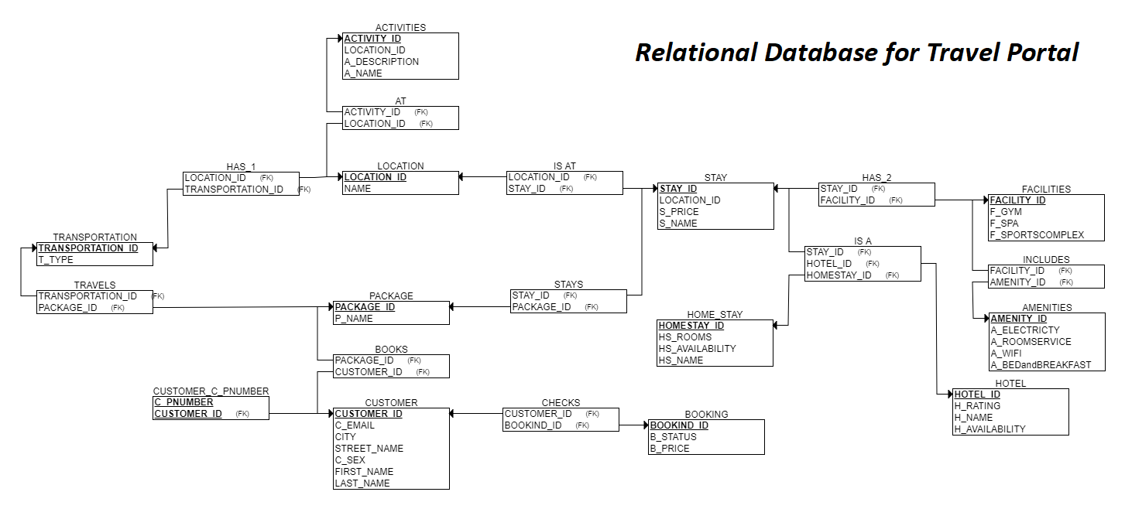

**Functional dependencies-**

1. **Activities-**

ACTIVITITY_ID --> A_DESCRIPTION

ACTIVITITY_ID --> A_NAME

1. **Location-**

LOCATION_ID --> L_NAME

1. **Transportation-**

TRANSPORTATION_ID --> T_NAME

1. **Stay-**

STAY_ID --> LOCATION_ID

STAY_ID --> S_PRICE

STAY_ID --> S_NAME

1. **Package-**

PACKAGE_ID --> P_NAME

1. **Customer-**

CUSTOMER_ID --> C_NAME

CUSTOMER_ID --> C_NUMBER

CUSTOMER_ID --> C_EMAIL

CUSTOMER_ID --> C_SEX

CUSTOMER_ID --> C_ADDRESS

1. **Facilities-**

FACILITY_ID --> F_GYM

FACILITY_ID --> F_SPA

FACILITY_ID --> F_SPORTSCOMPLEX

1. **Amenities-**

AMENITY_ID --> A_ELECTRICITY

AMENITY_ID --> A_ROOMSERVICE

AMENITY_ID --> A_WIFI

AMENITY_ID --> A_BEDandBREAKFAST

1. **Hotels-**

HOTEL_ID --> H_RATING

HOTEL_ID --> H_NAME

HOTEL_ID --> H_AVAILABILITY

1. **Home stay-**

HOMESTAY_ID --> HS_ROOMS

HOMESTAY_ID --> HS_AVAILABILITY

HOMESTAY_ID --> HS_NAME

1. **Booking-**

BOOKING_ID --> B_NAME

BOOKING_ID --> B_STATUS

BOOKING_ID --> B_PRICE